Start by opening Image Pro Plus on the desktop. Go to Macro and then select Trident (last one)

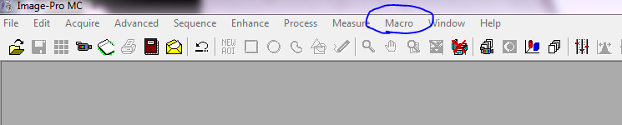

The macro will then ask for the file path: that will always be Z:\Sarah. Then hit OK.

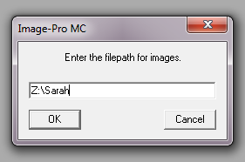

Next, it will ask to use this directory. You will say Yes.

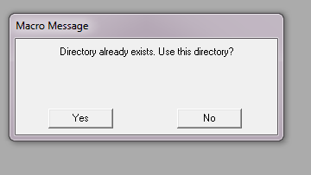

Then you need to calibrate the scale. Place the scale and keep hitting continue. We will ignore this procedure and instead take an image of the scale at the beginning of every day.

Once you have taken an image of the scale, Hit continue and then it will ask if you have a good image. Say yes. Then it will take you to save the picture. Label the image SCALE with date and time.

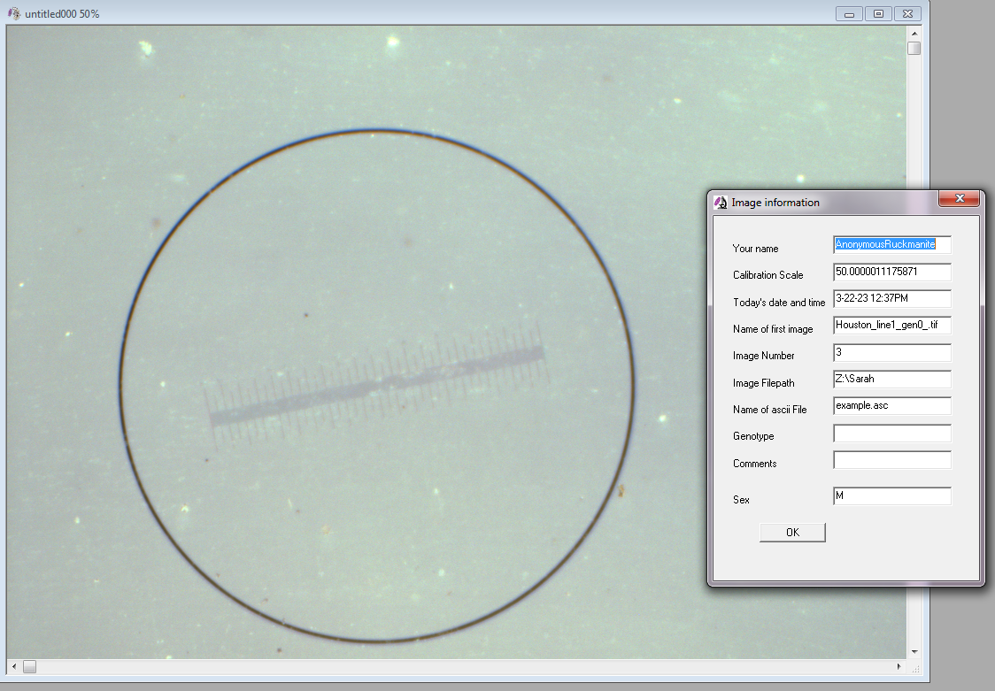

Now, you are ready to take fly photos. Once you have a good picture of the fly. Hit Continue. Then it will ask if you have a good image. Say yes or no. Then it will take you to save the picture.

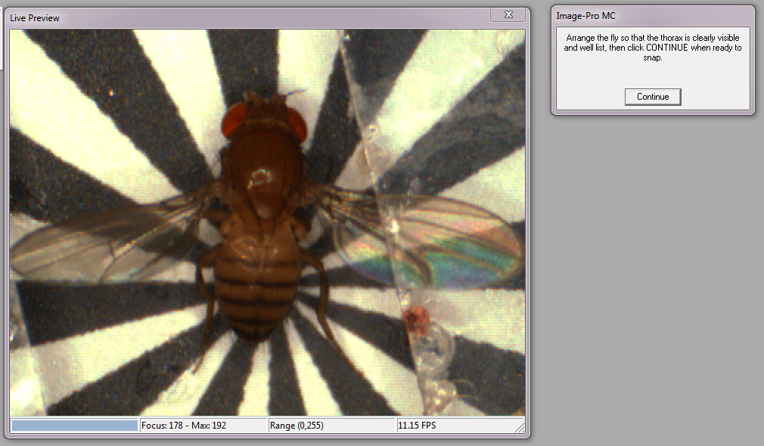

Write your name and anyone with you here.

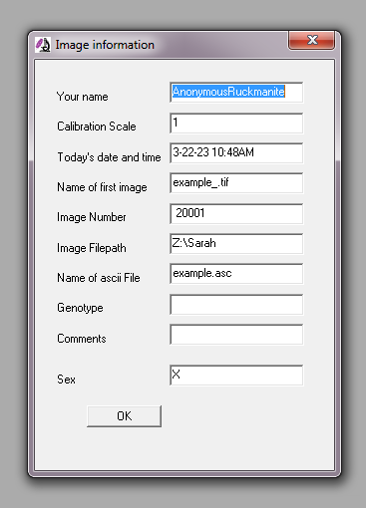

Any comments you have. Ex: I squished it

Change this to be the number that corresponds to the petri dish you have. You will need to change this every time.

Based on the information on the box, change this to be: Replicate_line#_gen#_.tif

Example: Houston_line1_gen0_.tif

Change this to be sex of the box (M or F)

Finally, it will ask you if you want to acquire another image. If are doing more, then say yes. If you are done for the day, say no and then you will be prompted if you want to exit the macro. Say yes to exit and then exit the program and turn off the computer.